1. A right circular cone base 50mm diameter and height 60mm rests symmetrically over a rectangular block 50mm x 40mm base and 30mm height. Draw the isometric view.

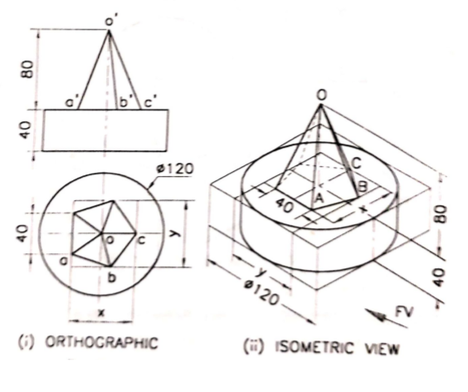

1. A cylinder slab 75mm in diameter and 20mm thick is surrounded by cube of 37mm side. On the top of the cube rests a square pyramid of altitude 37mm and side of base 25mm. The axis of solids are in same of line. Draw the isometric view of the combinations.

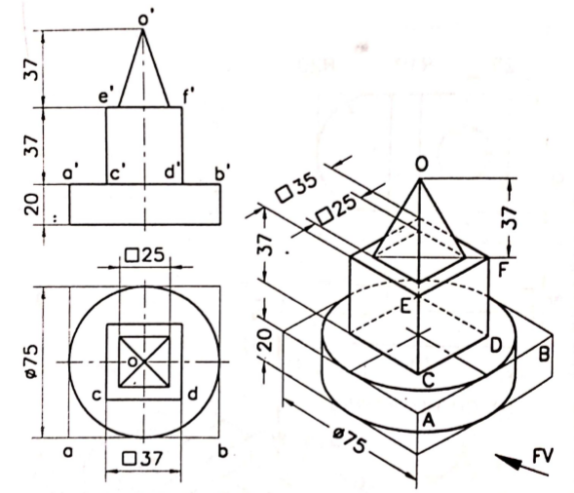

1. A hollow cylinder of inside diameter 40mm outside diameter 60mm and 80mm long is resting with its axis horizontal on a block 70mm square and 25mm thick. Draw an isometric view of the setup.

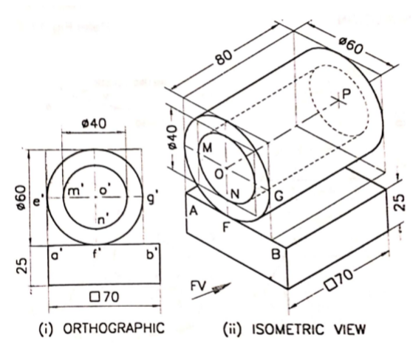

1. The frustum of a cone base diameter 40mm top face diameter 30mm and length of axis 60mm is resting centrally on the frustum of a hexagonal pyramid base 60mm side, top face 40mm and height 30mm. Draw the isometric projection of the compound solid.

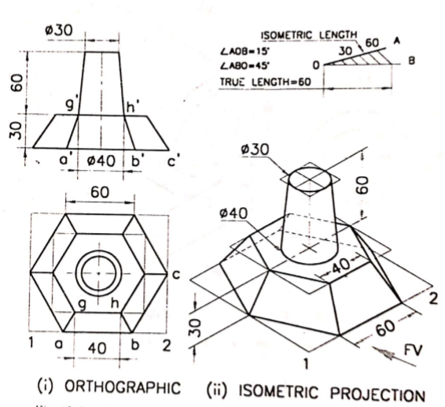

1. Draw the isometric view of the paper weight shown in figure below.

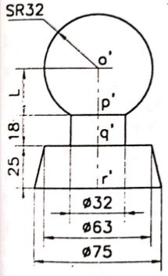

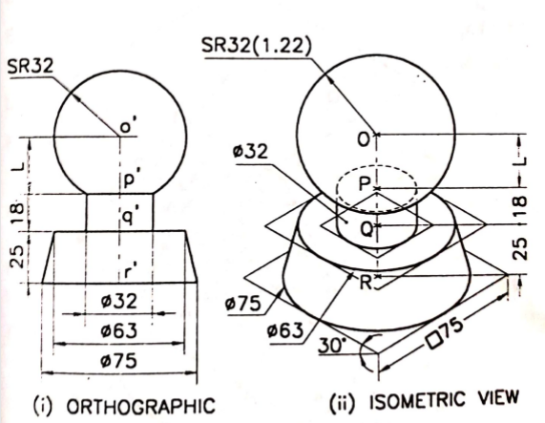

1. Draw the isometric view of a hexagonal pyramid of 35mm edge of base and height 70mm resting with its base on HP. It is truncated by a surface which is inclined at 30o to HP and perpendicular to VP. This plane passes through the mid point of the axis of the pyramid.

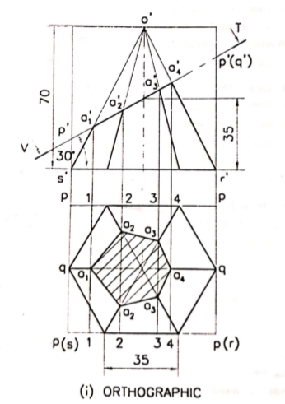

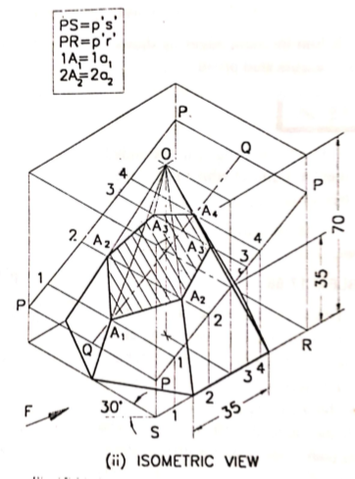

1. A square pyramid side of base 35mm and height 70mm is resting on the HP with the sides of base equally inclined to VP. It is cut by an inclined plane perpendicular to the VP and inclined at 30o to the HP through the midpoint of the vertical axis. Draw the isometric projection of the truncated pyramid.

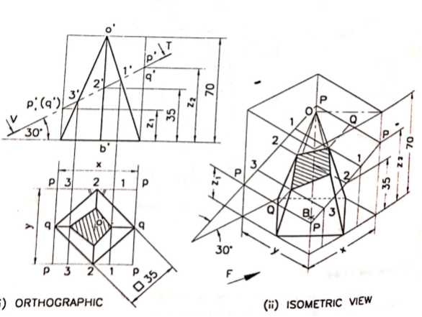

1. Draw the isomeric projection of bottom portion of cone of base diameter 50mm and height 80mm resting on its base in the HP and axis parallel to VP when it is cut by a cutting plane perpendicular to VP and inclined at 30o to the HP. The cutting plane cuts the axis at 40mm above its base.

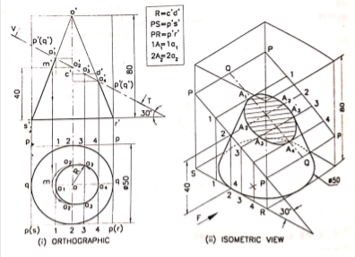

1. Draw a isometric view of a hemisphere diameter 60mm kept centrally plane surface upward on the frustum of a cone of base diameter 90mm top face diameter 50mm and height 40mm.

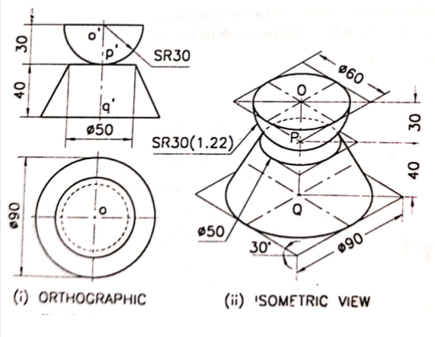

1. Orthographic view of handle is shown in figure. Draw its isometric view.

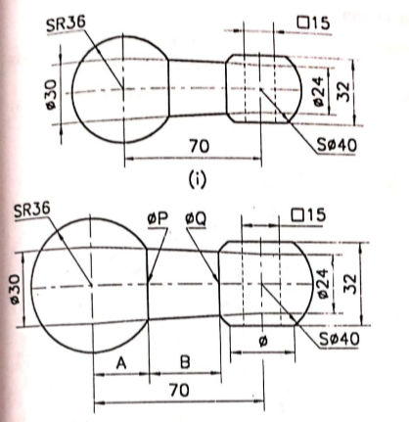

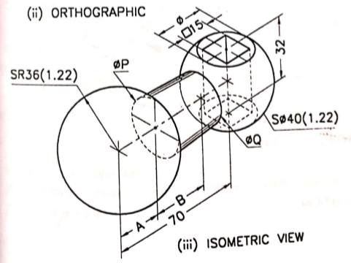

1. A hollow square prism standing up right has outside faces measuring 120mm x 100mm height, four inside faces measuring 100mm x 100mm high. A hemisphere of radius 54mm is resting with its curved surface on the prism and flat face horizontal. Draw the isometric projection of the combination as per standards

